**DVS Technologies Aws & Devops 1. Working with VPC**

**Creating a normal VPC and bringing one Ec2 from the customized VPC**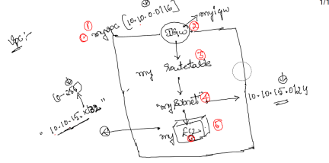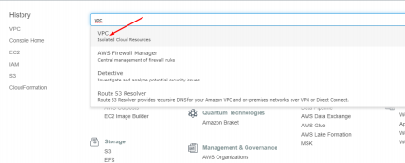

DVS Technologies, Opp Home Town, Beside Biryani Zone, Marathahalli, Bangalore Phone: 9632558585 Mobile: 8892499499 Mail : dvs.training@gmail.com Web: www.dvstechnologies.in

**DVS Technologies Aws & Devops** 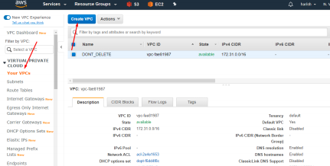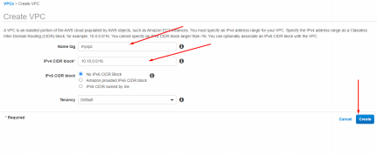

DVS Technologies, Opp Home Town, Beside Biryani Zone, Marathahalli, Bangalore Phone: 9632558585 Mobile: 8892499499 Mail : dvs.training@gmail.com Web: www.dvstechnologies.in

**DVS Technologies Aws & Devops** 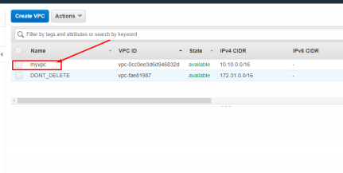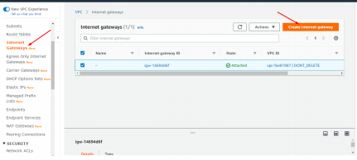

DVS Technologies, Opp Home Town, Beside Biryani Zone, Marathahalli, Bangalore Phone: 9632558585 Mobile: 8892499499 Mail : dvs.training@gmail.com Web: www.dvstechnologies.in

**DVS Technologies Aws & Devops** 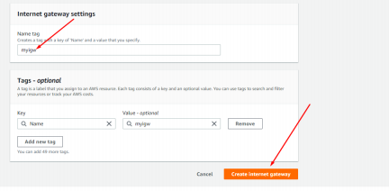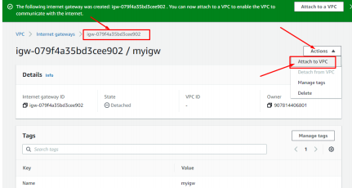

DVS Technologies, Opp Home Town, Beside Biryani Zone, Marathahalli, Bangalore Phone: 9632558585 Mobile: 8892499499 Mail : dvs.training@gmail.com Web: www.dvstechnologies.in

**DVS Technologies Aws & Devops** 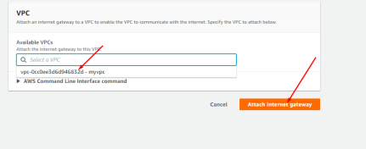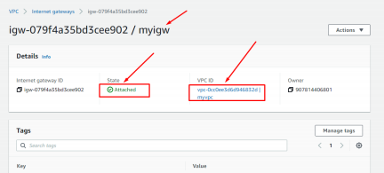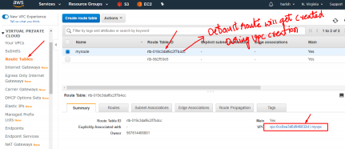

DVS Technologies, Opp Home Town, Beside Biryani Zone, Marathahalli, Bangalore Phone: 9632558585 Mobile: 8892499499 Mail : dvs.training@gmail.com Web: www.dvstechnologies.in

**DVS Technologies Aws & Devops** 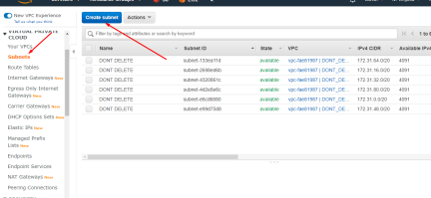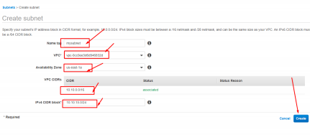

DVS Technologies, Opp Home Town, Beside Biryani Zone, Marathahalli, Bangalore Phone: 9632558585 Mobile: 8892499499 Mail : dvs.training@gmail.com Web: www.dvstechnologies.in

**DVS Technologies Aws & Devops** 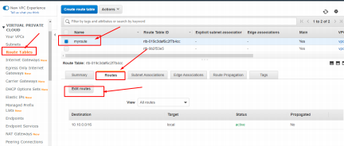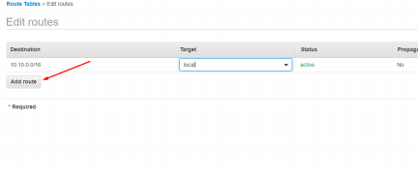

DVS Technologies, Opp Home Town, Beside Biryani Zone, Marathahalli, Bangalore Phone: 9632558585 Mobile: 8892499499 Mail : dvs.training@gmail.com Web: www.dvstechnologies.in

**DVS Technologies Aws & Devops **

DVS Technologies, Opp Home Town, Beside Biryani Zone, Marathahalli, Bangalore Phone: 9632558585 Mobile: 8892499499 Mail : dvs.training@gmail.com Web: www.dvstechnologies.in

**DVS Technologies Aws & Devops **

DVS Technologies, Opp Home Town, Beside Biryani Zone, Marathahalli, Bangalore Phone: 9632558585 Mobile: 8892499499 Mail : dvs.training@gmail.com Web: www.dvstechnologies.in

**DVS Technologies Aws & Devops **

DVS Technologies, Opp Home Town, Beside Biryani Zone, Marathahalli, Bangalore Phone: 9632558585 Mobile: 8892499499 Mail : dvs.training@gmail.com Web: www.dvstechnologies.in

**DVS Technologies Aws & Devops **

DVS Technologies, Opp Home Town, Beside Biryani Zone, Marathahalli, Bangalore Phone: 9632558585 Mobile: 8892499499 Mail : dvs.training@gmail.com Web: www.dvstechnologies.in

**DVS Technologies Aws & Devops **

DVS Technologies, Opp Home Town, Beside Biryani Zone, Marathahalli, Bangalore Phone: 9632558585 Mobile: 8892499499 Mail : dvs.training@gmail.com Web: www.dvstechnologies.in

**DVS Technologies Aws & Devops**

**2. Ec2 with Selected IPAddress**



DVS Technologies, Opp Home Town, Beside Biryani Zone, Marathahalli, Bangalore Phone: 9632558585 Mobile: 8892499499 Mail : dvs.training@gmail.com Web: www.dvstechnologies.in

**DVS Technologies Aws & Devops **

DVS Technologies, Opp Home Town, Beside Biryani Zone, Marathahalli, Bangalore Phone: 9632558585 Mobile: 8892499499 Mail : dvs.training@gmail.com Web: www.dvstechnologies.in

**DVS Technologies Aws & Devops**

Remaining 5 IP Details:



DVS Technologies, Opp Home Town, Beside Biryani Zone, Marathahalli, Bangalore Phone: 9632558585 Mobile: 8892499499 Mail : dvs.training@gmail.com Web: www.dvstechnologies.in

**DVS Technologies Aws & Devops 3. VPC with public & private subnets**



DVS Technologies, Opp Home Town, Beside Biryani Zone, Marathahalli, Bangalore Phone: 9632558585 Mobile: 8892499499 Mail : dvs.training@gmail.com Web: www.dvstechnologies.in

**DVS Technologies Aws & Devops **

DVS Technologies, Opp Home Town, Beside Biryani Zone, Marathahalli, Bangalore Phone: 9632558585 Mobile: 8892499499 Mail : dvs.training@gmail.com Web: www.dvstechnologies.in

**DVS Technologies Aws & Devops **

DVS Technologies, Opp Home Town, Beside Biryani Zone, Marathahalli, Bangalore Phone: 9632558585 Mobile: 8892499499 Mail : dvs.training@gmail.com Web: www.dvstechnologies.in

**DVS Technologies Aws & Devops **

DVS Technologies, Opp Home Town, Beside Biryani Zone, Marathahalli, Bangalore Phone: 9632558585 Mobile: 8892499499 Mail : dvs.training@gmail.com Web: www.dvstechnologies.in

**DVS Technologies Aws & Devops **

DVS Technologies, Opp Home Town, Beside Biryani Zone, Marathahalli, Bangalore Phone: 9632558585 Mobile: 8892499499 Mail : dvs.training@gmail.com Web: www.dvstechnologies.in

**DVS Technologies Aws & Devops **

DVS Technologies, Opp Home Town, Beside Biryani Zone, Marathahalli, Bangalore Phone: 9632558585 Mobile: 8892499499 Mail : dvs.training@gmail.com Web: www.dvstechnologies.in

**DVS Technologies Aws & Devops **

**Lets work on Private subnet creation:**

DVS Technologies, Opp Home Town, Beside Biryani Zone, Marathahalli, Bangalore Phone: 9632558585 Mobile: 8892499499 Mail : dvs.training@gmail.com Web: www.dvstechnologies.in

**DVS Technologies Aws & Devops **

DVS Technologies, Opp Home Town, Beside Biryani Zone, Marathahalli, Bangalore Phone: 9632558585 Mobile: 8892499499 Mail : dvs.training@gmail.com Web: www.dvstechnologies.in

**DVS Technologies Aws & Devops **

DVS Technologies, Opp Home Town, Beside Biryani Zone, Marathahalli, Bangalore Phone: 9632558585 Mobile: 8892499499 Mail : dvs.training@gmail.com Web: www.dvstechnologies.in

**DVS Technologies Aws & Devops **

**Lets create pub & priv servers:**

DVS Technologies, Opp Home Town, Beside Biryani Zone, Marathahalli, Bangalore Phone: 9632558585 Mobile: 8892499499 Mail : dvs.training@gmail.com Web: www.dvstechnologies.in

**DVS Technologies Aws & Devops **

DVS Technologies, Opp Home Town, Beside Biryani Zone, Marathahalli, Bangalore Phone: 9632558585 Mobile: 8892499499 Mail : dvs.training@gmail.com Web: www.dvstechnologies.in

**DVS Technologies Aws & Devops **

**NOTE: Similarly launch your private server with private subnet**



DVS Technologies, Opp Home Town, Beside Biryani Zone, Marathahalli, Bangalore Phone: 9632558585 Mobile: 8892499499 Mail : dvs.training@gmail.com Web: www.dvstechnologies.in

**DVS Technologies Aws & Devops **

**Testing Connectivity:**

**Public Server:**



DVS Technologies, Opp Home Town, Beside Biryani Zone, Marathahalli, Bangalore Phone: 9632558585 Mobile: 8892499499 Mail : dvs.training@gmail.com Web: www.dvstechnologies.in

**DVS Technologies Aws & Devops **

**PrivateServer Access:**



DVS Technologies, Opp Home Town, Beside Biryani Zone, Marathahalli, Bangalore Phone: 9632558585 Mobile: 8892499499 Mail : dvs.training@gmail.com Web: www.dvstechnologies.in

**DVS Technologies Aws & Devops **

**Now Lets connect private server from our public server:**



DVS Technologies, Opp Home Town, Beside Biryani Zone, Marathahalli, Bangalore Phone: 9632558585 Mobile: 8892499499 Mail : dvs.training@gmail.com Web: www.dvstechnologies.in

**DVS Technologies Aws & Devops **

DVS Technologies, Opp Home Town, Beside Biryani Zone, Marathahalli, Bangalore Phone: 9632558585 Mobile: 8892499499 Mail : dvs.training@gmail.com Web: www.dvstechnologies.in

**DVS Technologies Aws & Devops **

DVS Technologies, Opp Home Town, Beside Biryani Zone, Marathahalli, Bangalore Phone: 9632558585 Mobile: 8892499499 Mail : dvs.training@gmail.com Web: www.dvstechnologies.in

**DVS Technologies Aws & Devops 4. VPC Peering in the same region**



**Creating HydVpc:**



DVS Technologies, Opp Home Town, Beside Biryani Zone, Marathahalli, Bangalore Phone: 9632558585 Mobile: 8892499499 Mail : dvs.training@gmail.com Web: www.dvstechnologies.in

**DVS Technologies Aws & Devops **

DVS Technologies, Opp Home Town, Beside Biryani Zone, Marathahalli, Bangalore Phone: 9632558585 Mobile: 8892499499 Mail : dvs.training@gmail.com Web: www.dvstechnologies.in

**DVS Technologies Aws & Devops **

DVS Technologies, Opp Home Town, Beside Biryani Zone, Marathahalli, Bangalore Phone: 9632558585 Mobile: 8892499499 Mail : dvs.training@gmail.com Web: www.dvstechnologies.in

**DVS Technologies Aws & Devops **

DVS Technologies, Opp Home Town, Beside Biryani Zone, Marathahalli, Bangalore Phone: 9632558585 Mobile: 8892499499 Mail : dvs.training@gmail.com Web: www.dvstechnologies.in

**DVS Technologies Aws & Devops **

DVS Technologies, Opp Home Town, Beside Biryani Zone, Marathahalli, Bangalore Phone: 9632558585 Mobile: 8892499499 Mail : dvs.training@gmail.com Web: www.dvstechnologies.in

**DVS Technologies Aws & Devops **DVS Technologies, Opp Home Town, Beside Biryani Zone, Marathahalli, Bangalore Phone: 9632558585 Mobile: 8892499499 Mail : dvs.training@gmail.com Web: www.dvstechnologies.in

**DVS Technologies Aws & Devops **

**Lets launch one EC2 from our hyd vpc:**



DVS Technologies, Opp Home Town, Beside Biryani Zone, Marathahalli, Bangalore Phone: 9632558585 Mobile: 8892499499 Mail : dvs.training@gmail.com Web: www.dvstechnologies.in

**DVS Technologies Aws & Devops **

DVS Technologies, Opp Home Town, Beside Biryani Zone, Marathahalli, Bangalore Phone: 9632558585 Mobile: 8892499499 Mail : dvs.training@gmail.com Web: www.dvstechnologies.in

**DVS Technologies Aws & Devops **

**NOTE: PLEASE FOLLOW THE ABOVE STEPS FOR YOUR BLR VPC & EC2 CREATION**

**Now lets work on connecting these two diff ip range servers:**

DVS Technologies, Opp Home Town, Beside Biryani Zone, Marathahalli, Bangalore Phone: 9632558585 Mobile: 8892499499 Mail : dvs.training@gmail.com Web: www.dvstechnologies.in

**DVS Technologies Aws & Devops **

**Enable VPC Peering:**

DVS Technologies, Opp Home Town, Beside Biryani Zone, Marathahalli, Bangalore Phone: 9632558585 Mobile: 8892499499 Mail : dvs.training@gmail.com Web: www.dvstechnologies.in

**DVS Technologies Aws & Devops **

DVS Technologies, Opp Home Town, Beside Biryani Zone, Marathahalli, Bangalore Phone: 9632558585 Mobile: 8892499499 Mail : dvs.training@gmail.com Web: www.dvstechnologies.in

**DVS Technologies Aws & Devops **

DVS Technologies, Opp Home Town, Beside Biryani Zone, Marathahalli, Bangalore Phone: 9632558585 Mobile: 8892499499 Mail : dvs.training@gmail.com Web: www.dvstechnologies.in

**DVS Technologies Aws & Devops **

DVS Technologies, Opp Home Town, Beside Biryani Zone, Marathahalli, Bangalore Phone: 9632558585 Mobile: 8892499499 Mail : dvs.training@gmail.com Web: www.dvstechnologies.in

**DVS Technologies Aws & Devops **

DVS Technologies, Opp Home Town, Beside Biryani Zone, Marathahalli, Bangalore Phone: 9632558585 Mobile: 8892499499 Mail : dvs.training@gmail.com Web: www.dvstechnologies.in

**DVS Technologies Aws & Devops **

DVS Technologies, Opp Home Town, Beside Biryani Zone, Marathahalli, Bangalore Phone: 9632558585 Mobile: 8892499499 Mail : dvs.training@gmail.com Web: www.dvstechnologies.in

**DVS Technologies Aws & Devops **

DVS Technologies, Opp Home Town, Beside Biryani Zone, Marathahalli, Bangalore Phone: 9632558585 Mobile: 8892499499 Mail : dvs.training@gmail.com Web: www.dvstechnologies.in

**DVS Technologies Aws & Devops **

**5. VPC Peering across regions**

DVS Technologies, Opp Home Town, Beside Biryani Zone, Marathahalli, Bangalore Phone: 9632558585 Mobile: 8892499499 Mail : dvs.training@gmail.com Web: www.dvstechnologies.in

**DVS Technologies Aws & Devops Perform below in N.Virginia Region:**



DVS Technologies, Opp Home Town, Beside Biryani Zone, Marathahalli, Bangalore Phone: 9632558585 Mobile: 8892499499 Mail : dvs.training@gmail.com Web: www.dvstechnologies.in

**DVS Technologies Aws & Devops **DVS Technologies, Opp Home Town, Beside Biryani Zone, Marathahalli, Bangalore Phone: 9632558585 Mobile: 8892499499 Mail : dvs.training@gmail.com Web: www.dvstechnologies.in

**DVS Technologies Aws & Devops **

DVS Technologies, Opp Home Town, Beside Biryani Zone, Marathahalli, Bangalore Phone: 9632558585 Mobile: 8892499499 Mail : dvs.training@gmail.com Web: www.dvstechnologies.in

**DVS Technologies Aws & Devops **

DVS Technologies, Opp Home Town, Beside Biryani Zone, Marathahalli, Bangalore Phone: 9632558585 Mobile: 8892499499 Mail : dvs.training@gmail.com Web: www.dvstechnologies.in

**DVS Technologies Aws & Devops **

DVS Technologies, Opp Home Town, Beside Biryani Zone, Marathahalli, Bangalore Phone: 9632558585 Mobile: 8892499499 Mail : dvs.training@gmail.com Web: www.dvstechnologies.in

**DVS Technologies Aws & Devops **

DVS Technologies, Opp Home Town, Beside Biryani Zone, Marathahalli, Bangalore Phone: 9632558585 Mobile: 8892499499 Mail : dvs.training@gmail.com Web: www.dvstechnologies.in

**DVS Technologies Aws & Devops **

**Create EC2 in N.virginia region:**

DVS Technologies, Opp Home Town, Beside Biryani Zone, Marathahalli, Bangalore Phone: 9632558585 Mobile: 8892499499 Mail : dvs.training@gmail.com Web: www.dvstechnologies.in

**DVS Technologies Aws & Devops **

DVS Technologies, Opp Home Town, Beside Biryani Zone, Marathahalli, Bangalore Phone: 9632558585 Mobile: 8892499499 Mail : dvs.training@gmail.com Web: www.dvstechnologies.in

**DVS Technologies Aws & Devops **

DVS Technologies, Opp Home Town, Beside Biryani Zone, Marathahalli, Bangalore Phone: 9632558585 Mobile: 8892499499 Mail : dvs.training@gmail.com Web: www.dvstechnologies.in

**DVS Technologies Aws & Devops **

**NOTE: PLEASE PERFORM THE ABOVE STEPS IN N.CALIFORNIA REGION Once you are done you will get like below**

DVS Technologies, Opp Home Town, Beside Biryani Zone, Marathahalli, Bangalore Phone: 9632558585 Mobile: 8892499499 Mail : dvs.training@gmail.com Web: www.dvstechnologies.in

**DVS Technologies Aws & Devops **

**Testing the connectivity:**

DVS Technologies, Opp Home Town, Beside Biryani Zone, Marathahalli, Bangalore Phone: 9632558585 Mobile: 8892499499 Mail : dvs.training@gmail.com Web: www.dvstechnologies.in

**DVS Technologies Aws & Devops **

**Now Configure Peering across the regions:**

**Perform below from N.Virginia region**



DVS Technologies, Opp Home Town, Beside Biryani Zone, Marathahalli, Bangalore Phone: 9632558585 Mobile: 8892499499 Mail : dvs.training@gmail.com Web: www.dvstechnologies.in

**DVS Technologies Aws & Devops **

DVS Technologies, Opp Home Town, Beside Biryani Zone, Marathahalli, Bangalore Phone: 9632558585 Mobile: 8892499499 Mail : dvs.training@gmail.com Web: www.dvstechnologies.in

**DVS Technologies Aws & Devops **

DVS Technologies, Opp Home Town, Beside Biryani Zone, Marathahalli, Bangalore Phone: 9632558585 Mobile: 8892499499 Mail : dvs.training@gmail.com Web: www.dvstechnologies.in

**DVS Technologies Aws & Devops **

**Let again check the connectivity:**



DVS Technologies, Opp Home Town, Beside Biryani Zone, Marathahalli, Bangalore Phone: 9632558585 Mobile: 8892499499 Mail : dvs.training@gmail.com Web: www.dvstechnologies.in

**DVS Technologies Aws & Devops Now perform below in California:**



DVS Technologies, Opp Home Town, Beside Biryani Zone, Marathahalli, Bangalore Phone: 9632558585 Mobile: 8892499499 Mail : dvs.training@gmail.com Web: www.dvstechnologies.in

**DVS Technologies Aws & Devops **

DVS Technologies, Opp Home Town, Beside Biryani Zone, Marathahalli, Bangalore Phone: 9632558585 Mobile: 8892499499 Mail : dvs.training@gmail.com Web: www.dvstechnologies.in

**DVS Technologies Aws & Devops**

**6. Endpoint Configuration**



DVS Technologies, Opp Home Town, Beside Biryani Zone, Marathahalli, Bangalore Phone: 9632558585 Mobile: 8892499499 Mail : dvs.training@gmail.com Web: www.dvstechnologies.in

**DVS Technologies Aws & Devops **

DVS Technologies, Opp Home Town, Beside Biryani Zone, Marathahalli, Bangalore Phone: 9632558585 Mobile: 8892499499 Mail : dvs.training@gmail.com Web: www.dvstechnologies.in

**DVS Technologies Aws & Devops **

DVS Technologies, Opp Home Town, Beside Biryani Zone, Marathahalli, Bangalore Phone: 9632558585 Mobile: 8892499499 Mail : dvs.training@gmail.com Web: www.dvstechnologies.in

**DVS Technologies Aws & Devops **

**Let's Concentrate on Pub section:**

DVS Technologies, Opp Home Town, Beside Biryani Zone, Marathahalli, Bangalore Phone: 9632558585 Mobile: 8892499499 Mail : dvs.training@gmail.com Web: www.dvstechnologies.in

**DVS Technologies Aws & Devops **

DVS Technologies, Opp Home Town, Beside Biryani Zone, Marathahalli, Bangalore Phone: 9632558585 Mobile: 8892499499 Mail : dvs.training@gmail.com Web: www.dvstechnologies.in

**DVS Technologies Aws & Devops **

DVS Technologies, Opp Home Town, Beside Biryani Zone, Marathahalli, Bangalore Phone: 9632558585 Mobile: 8892499499 Mail : dvs.training@gmail.com Web: www.dvstechnologies.in

**DVS Technologies Aws & Devops **DVS Technologies, Opp Home Town, Beside Biryani Zone, Marathahalli, Bangalore Phone: 9632558585 Mobile: 8892499499 Mail : dvs.training@gmail.com Web: www.dvstechnologies.in

**DVS Technologies Aws & Devops **

DVS Technologies, Opp Home Town, Beside Biryani Zone, Marathahalli, Bangalore Phone: 9632558585 Mobile: 8892499499 Mail : dvs.training@gmail.com Web: www.dvstechnologies.in

**DVS Technologies Aws & Devops **

**Let's Configure Private Section:**

DVS Technologies, Opp Home Town, Beside Biryani Zone, Marathahalli, Bangalore Phone: 9632558585 Mobile: 8892499499 Mail : dvs.training@gmail.com Web: www.dvstechnologies.in

**DVS Technologies Aws & Devops **

DVS Technologies, Opp Home Town, Beside Biryani Zone, Marathahalli, Bangalore Phone: 9632558585 Mobile: 8892499499 Mail : dvs.training@gmail.com Web: www.dvstechnologies.in

**DVS Technologies Aws & Devops **

DVS Technologies, Opp Home Town, Beside Biryani Zone, Marathahalli, Bangalore Phone: 9632558585 Mobile: 8892499499 Mail : dvs.training@gmail.com Web: www.dvstechnologies.in

**DVS Technologies Aws & Devops **

**Now let's create our Private Ec2 server:**

DVS Technologies, Opp Home Town, Beside Biryani Zone, Marathahalli, Bangalore Phone: 9632558585 Mobile: 8892499499 Mail : dvs.training@gmail.com Web: www.dvstechnologies.in

**DVS Technologies Aws & Devops **

DVS Technologies, Opp Home Town, Beside Biryani Zone, Marathahalli, Bangalore Phone: 9632558585 Mobile: 8892499499 Mail : dvs.training@gmail.com Web: www.dvstechnologies.in

**DVS Technologies Aws & Devops Logging in to Private Server:**



DVS Technologies, Opp Home Town, Beside Biryani Zone, Marathahalli, Bangalore Phone: 9632558585 Mobile: 8892499499 Mail : dvs.training@gmail.com Web: www.dvstechnologies.in